For the exam, we just need to understand the basic things because we are not expected to be mathematicians.

What we learned so far and need to remember is adding vectors. We talked about addition of organized arrays, translational symmetry, the lattices and we came into function that show the lattice is actually amplifier, which selectively amplify at certain scattering factor (direction/frequency).

How to apply this in physical reality? The lattice represents the crystals which contain translational symmetry.

So how we obtain crystals? (Lecture 5) This is a difficult process for proteins. From previous class, we learnt how to change the concentration of precipitating agent slowly over a narrow range of concentration by equilibration.

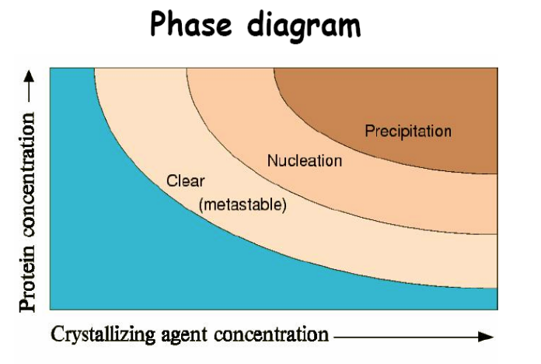

To get to that point, we need to make protein to nearly saturated stage. The concentration we need is 5-10 µg/µl. For usual protein purification technique, the concentration of pure protein that we get is less than 1 µg/µl. We can’t go into crystallization from that concentration because the protein can never get into the metastable and the nucleation zone.

So the first thing we do is to concentrate the protein. An old-fashioned way to do this is to do precipitation with 60% ammonium sulphate and then dissolve it in a known amount of liquid. Nowadays, people usually use Centricon or Amicon.

Dr. Cygler went over a few slides about generating X-ray source. He emphasized the advantages of synchrotron over home source. The first advantage is it allows you to get a MUCH stronger (10⁵ times) intensity. Second is the tunability, which is needed in the anomalous diffraction technique where a continuous range of wavelength is needed.

Then it’s summary for lecture 6. What is the phase problem? From the experiment, we only get the magnitude 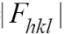and not the phase 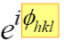. So we lost the phase information. We need both magnitude and phase to find the structure factor 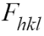. There are three solutions to this problem.

Isomorphous replacement

Basically is putting an extra marker that is big and heavy (~3 times in size of our unit cell) and measures the change in diffraction pattern. We measure the contribution of the marker and the unit cells and we can draw the ‘triangle’. From last class, we know that we will get 2 possible phases if we just use 1 marker (lecture 6 slide 5). So we need to put another marker in order to get the ‘correct’ phase. Therefore in total, we are taking 3 measurements. First on our native crystal. The second is after adding our 1st marker. And the third is after adding our 2nd marker. We have to use a new set of crystals after each measurement because X-ray is pretty destructive and crystals can’t stay long under x-ray. They may still look good but their diffraction patterns do not. This is the main problem of the technique. We are combining measurements from 3 non-identical samples and this gives error. In short, the principle of this technique is to add external markers and use simple trigonometry to figure out the phase, but the experimental error is huge due to non-identical crystals used.

Anomalous diffraction

Electrons will absorb energy and be excited to a higher energy level when the energy is the same as the energy gap between the two energy levels. The electron therefore shows strong absorption at narrow range of wavelength. This wavelength is around 0.7-1.5Å, which is exactly the area where we do our measurement.

What does that mean? For every wavelength, we take 1 measurement. As we change the wavelength (continuously) to a point that the corresponding energy is near the excitation energy of one of the electron, this electron will have strong absorption and diffract stronger. The crystal itself doesn’t change. We are not replacing anything; we are just changing the wavelength. Though the difference in scattering is not that big (about 4-5 electrons), the important point is that we are using the same crystals, which have the same shape, same volume, and in same liquid, etc. so some errors may cancel out themselves when we are looking for differences.

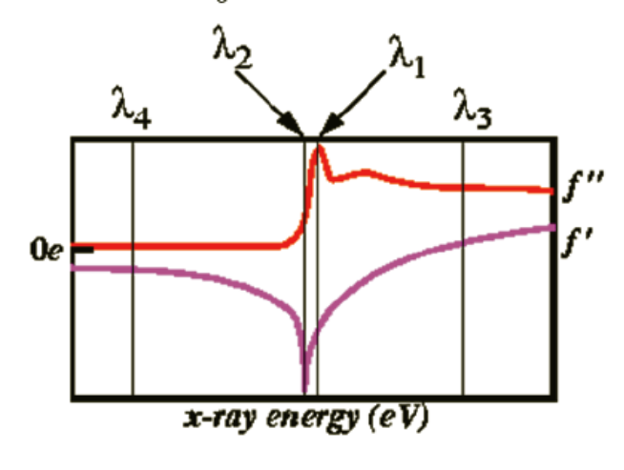
In the above figure, positive value means the ‘additional’ scattering of the electron on top of the amplitude of the normal scattering from an atom. We are talking about f ” (just forget about f ’), which is 90º off from the real contribution due to the absorption of energy and the time delay in re-emission of photon. This +90 º phase difference break the Friedel pair relationship because symmetry is broken. (Fp and Fa is always in plane symmetry, i.e. positive for hkl and negative for –h-k-l. But f ” is always positive).

The point here is that with 2 wavelengths, we are have 2 independent measurements (hkl and –h-k-l). If this is isomorphous replacement, these 2 measurements are identical because of Friedel pair relationship (and that’s why we need 2nd marker). In anomalous diffraction, since this relationship is broken, there are differences between them (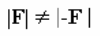and ). So in one experiment, we are actually having 2 measurements, at hkl and –h-k-l. Therefore, we can derive the phase directly. Dr. Cygler mentioned that for the last slide of lecture 6, you can forget it if you can’t figure it out. Just remember the principle of the technique. Actually it is similar to isomorphous replacement, only that this time we change the wavelength to increase the absorption of one of the atoms and this atom contributes significantly to anomalous scattering. We therefore obtain phase information using same sample and without adding external markers.

The atom that is being used widely nowadays is selenium (Se). We’d usually prefer to use heavier atoms like mercury, but the advantage of using the lighter Se is that we can introduce it to our crystals using molecular biology. We either have E.Coli. strains that do not make methionine and grow them in medium with Se-Met, or growing the regular strains in a medium that suppresses methionine biosynthesis. More than 90% of Se-Met can be incorporated in both methods. We can then locate the Se which replace the sulphur in Met. Then we do the construction for each reflection and get the phases.

Q: Why we can derive the phase using only two measurements in anomalous diffraction,
but we need 3 measurements in isomorphous replacement?

A. Basis: 3 measurements are needed to find the phase.
Isomorphous replacement: 3 crystal samples (native, 1st marker, 2nd marker). hkl and -h-k-l is the same so that only 1 measurement can be get for each sample.
Anomalous diffraction: Due to difference in hkl and -h-k-l, if we measure both positive and negative (on the same sample), we have 2 measurements instead of just 1. Each derivative gives us one extra measurement. We got anomalous dispersion collecting data from entire crystals. We can still get the phase because we do measurements on native, and then we get information on hkl and -h-k-l. So there are actually three measurements.

Finally: Lecture 7
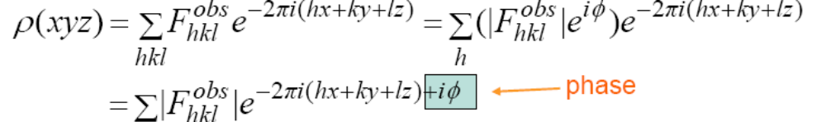
Again, 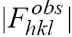 is the amplitude we get from our experiment and 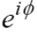 is the phase which we didn’t get. Both are needed to calculate the structure factor.

But if there is no phase information, we can still calculate the Patterson function, which use intensity 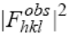 instead of amplitude.

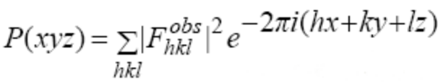
← no phase

Since no phase information is needed to find P (xyz), we can calculate it directly from the experiment.

Dr. Cygler asked us to have faith in him for the following:
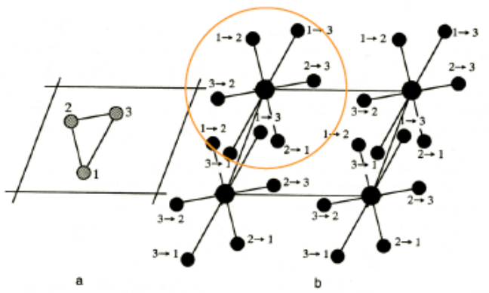
Say if we have a molecule of three atoms as in the left figure. If one calculate ρ(xyz), we will get maximum electron density at the three corners corresponding to the position of the atoms. But if we look at Patterson function P(xyz), there will be many peaks corresponding to vectors (not only distance) between any of the 2 atoms (e.g. vector of 1→2, 1→3, 3→1) (The right figure). Patterson function is a centro-symmetric function. We have many more peaks (instead of just 3) which we can make model from. It may look like a mess, but sometimes they can actually be interpreted. Since every atom equals to 0 vector from itself, each atom can act as origin. The height of the peak represents the number of electrons in atom 1 times that in atom 2. Since all atoms contribute to electron density in the origin, the peak at origin is huge and this gives us no information. We can discard this peak. The other peaks (contributed by 1 atom) can actually tell us the atomic arrangement. So if afterwards, we know the position of all these peaks, we can recover the shape of the molecule by doing some math.

Still there will be a resolution problem. Small peaks and those not too far away merge together. Just as in the following figure when we try to purify something.

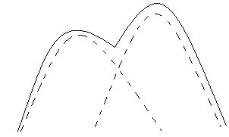
We know that there are two components. But we simply can’t resolve it.

So if we don’t know the position of all the peaks, we can’t recover the whole molecule (even we know their Patterson functions).
If we take that three atoms and rotate it by 30º, P(xyz) also rotate 30 º , i.e. P(xyz) keeps the orientation information of the molecule. Of course there can be another molecule in the next unit cell, which there can be vectors between the atom of this unit cell and the next one. But this vector will be far away from our origin. So the important thing is that we should look close to our origin, for example, within 5Å (our molecule size). We know that the peaks within this distance represent vectors within that unit cell only. This tells us the orientation (predominantly peaks) within the same molecule.

Molecular replacement

This method allows us to make predictions to unknown structure by looking at proteins with similar amino acid sequence.

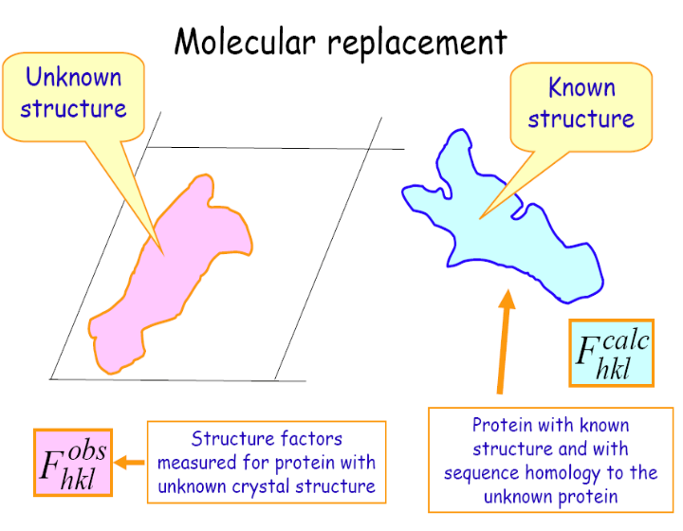
A good sequence homology is around ~35%. With this percentage of homology, the proteins are likely to have similar shapes, so the protein with the known structure might be a good starting model for us. The question we have to find out is what orientation of our molecule that will fit in the unit cells of the model and then where it is located in this unit cell to get a structure factor. So, if we have a model, we know some positions and we can calculate structure factor.

Background: Correlation goes from -1 to +1. 0 means no correlation at all. +1 means identical except from a scale factor and -1 means exactly the opposite.

We first put the model molecule placing the unit cell randomly and calculate structure factor from this. We have 2 sets of structure factor, Fobs (what we observe) and Fcalc (from our model). We then look at the correlation of the 2 structure factors. If the correlation is low, we keep on changing the orientation until the correlation becomes high. Both the orientation and position have to be considered. So it is a 6D search. Together, there will be 3 degree of freedom for rotation (α, β, γ) and 3 for translation (x, y, z). For example if alpha can be 0 to 360º, and we want to check 20 positions. Then for each of the 6 dimension, we have to test 20 times. So we have to do 20⁶ computations. This takes months on computer and the worse part is we have to monitor our sample closely because we may miss the good correlation by just a few degree off. So this is a nice method, but not too practical.

So instead of correlating structure factors, we try to find the correlation of Patterson function from the experiment 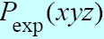 and calculated 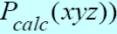 from model. Since P(xyz) is only about orientation, what we are looking at will be within a molecule (provided near the origin), the location is not important here. We just look at angular space and search for angles. This makes is a 3D search (α, β, γ). After finding the orientation with high correlations between Patterson function, we can now see where the molecule is located in this unit cell by looking at other 3D (xyz), which correlates the structure factors that depend on both orientation and location. So the computation, for example if we want to check 10 points, is reduced from a million (10⁶) to 2000 (2X10³). Though we will lose a bit of precision because of noise originates from the interactions between molecules. But this method is really fast. We use fast Fourier transform algorithm to calculate the Patterson function. It’s just 1-2 minutes and it will be weeks for a 6D search.

We use Patterson function because when it’s near the origin, it is insensitive to the position of the molecule, it is only sensitive to orientation because there, you only have intramolecular vectors. Even if we have another molecule next to us, the distance of the atoms in 2 different molecules is much greater than that within an atom. So in Patterson function, they are far away from the origin. (Patterson function has nothing to do with bonds, we are dealing with the atoms)

The model we get allows us to find phases (since phase is known for out model). But we can’t stop here because remember our unknown protein is still not the protein model that we start with. This is the BEST fit of our observation, but still may not fit very well.

Slide 6 shows how electron density look like at different resolutions. You can see that from 3Å onwards, it becomes a kind of blob. So resolution should best be smaller than 2.5 Å to get details.

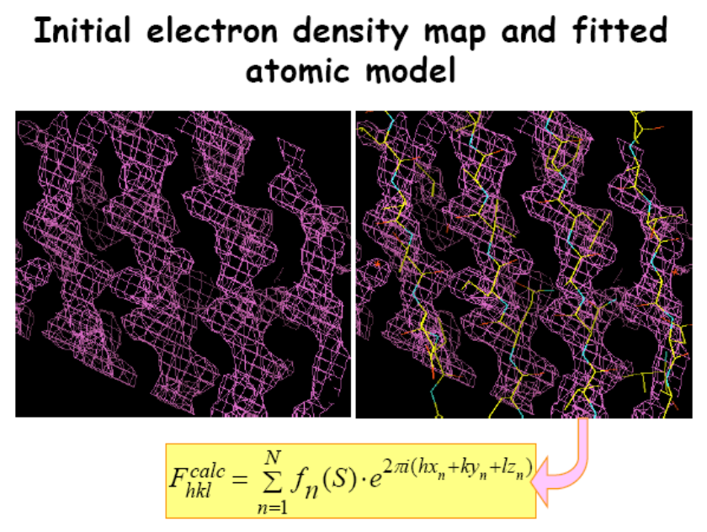
The general method to calculate structure factor is to combine the initial phase (which is found from any of the three methods) and the observed amplitude 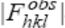.

1. The electron density map on the left represents polypeptide chains. The map is calculated from our measured amplitude of structure factor and the initial phases found by 1 of the three methods mentioned.

2. Then we try to build a model base on the map and fit in atoms. The parts that stick out most probably correspond to side chains and just by looking at the shape of the electron density, we can guess what the side chains are.

3. After building this atomic model, we can use it to calculate structure factor. And this gives the modulus of the scattering value 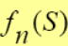 and hence the calculated factor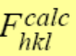.

We can test how good our model is by finding R-factor.

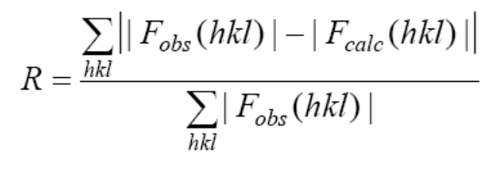

If our structure is good, 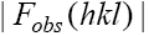 (from experiment) and 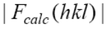 (from density map) is the same. So the numerator is zero. The denominator is just for normalization.

If R = 0.55, you get a lousy model. It is probably just a random distribution of atoms. A good range will be 20%+2 If you get 0.3, then it’s ok but maybe something is not interpreted correctly, if at all.

To refine our initial model, we may make 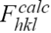closer to our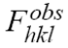. The observed intensity 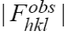 is what we measured and we trust it. and 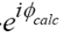 are what we calculated. And 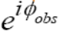 is something we don’t know. So we combine the equation. The best possible estimate of structure factor at this stage is a combination of with the phase difference calculated from our model. If we then use 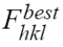 to calculate electron density, the electron intensity maybe more informative than the previous one that we calculated with poor (initial) phases. And so we can go and change our model to fit the electron density a bit better.
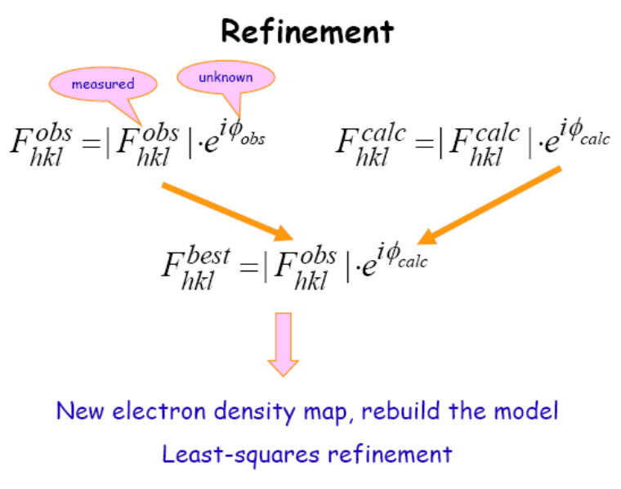
The least square refinement is actually some maths tricks. We minimize the difference between and by moving the atom.

Since we have to fill in our evaluation forms, we have no time to cover density modification in detail. The basic thing here is noises are everywhere (which means peaks appear at places where they shouldn’t be) because phases contain errors. In a crystal, protein and solvent content is about 50/50. We assume that solvent does not contribute to the electron density. So we can draw a mask around the area which we think our protein might be (according to electron density), saying that area outside that mask is solvent, and therefore say the electron density there is 0. This is called solvent flattening. From this electron density map, we get a modified map. With this modified electron density map, we can then calculate new structure factors and phases, combine them with observed structure factors and we go through it several times until we get the conventions.

